**Role of Artificial Intelligence in Healthcare**

**Ishit Arhatia1, Omkar Patange2, Deeba Kannan3**

1SRM Institute of Science and Technology, Kattankulathur, Chennai, Tamil Nadu(iarhatia@gmail.com)

2SRM Institute of Science and Technology, Kattankulathur, Chennai, Tamil Nadu(work.omkarpatange@gmail.com)

3SRM Institute of Science and Technology, Kattankulathur, Chennai, Tamil Nadu (deebak@srmist.edu.in)

# Abstract

The integration of Artificial Intelligence (AI) into healthcare systems has garnered increasing attention for its potential to revolutionize patient care, diagnosis, and treatment. This research paper delves into the multifaceted landscape of AI in healthcare, examining the perspectives of both health professionals and laymen on the role of AI in shaping the future of medical practices. The study employs a dual-method approach, incorporating surveys administered to health professionals and laymen to gather comprehensive insights. Health professionals, including physicians, nurses, veterinarians, students, and allied health practitioners, were surveyed to assess their perceptions of AI's impact on clinical decision-making, workflow efficiency, and patient outcomes. Additionally, laymen, representing diverse demographic backgrounds, were surveyed to gauge their attitudes, expectations, and concerns regarding the integration of AI into healthcare services. Through a quantitative and qualitative analysis of the survey data, this paper aims to identify common themes, disparities, and potential areas of collaboration between health professionals and the general public in adopting AI technologies. The findings will contribute to a nuanced understanding of the current sentiments surrounding AI in healthcare, addressing ethical considerations, trust-building measures, and the need for effective communication between healthcare providers and the broader community. Ultimately, this research strives to inform policymakers, healthcare practitioners, and technology developers about the key factors influencing the successful integration of AI in healthcare, fostering a collaborative and patient-centric approach toward the advancement of this transformative technology in the medical domain.

**Keywords**

Artificial Intelligence, machine learning, survey, health professionals, respondents, healthcare

# 1. Introduction

The integration of Artificial Intelligence (AI) into healthcare systems has emerged as a transformative force with the potential to revolutionize various facets of patient care, diagnosis, and treatment. AI is becoming a cornerstone of the healthcare industry; Electronic medical records (EMRs) are now widespread, generating a wealth of data that can be used for disease diagnosis, treatment effectiveness evaluation, and care recommendations. AI will increasingly assist physicians by processing vast amounts of diagnostic and treatment data[25]. This research paper aims to delve into the multifaceted landscape of AI in healthcare, shedding light on the perspectives of both health professionals and laymen regarding the role of AI in shaping the future of medical practices.

AI technologies encompass a diverse range of applications within healthcare, ranging from diagnostic tools and predictive analytics to personalized treatment plans and robotic surgeries. The integration of machine learning algorithms and data-driven approaches has the potential to enhance clinical decision-making, streamline workflow efficiency, and ultimately improve patient outcomes. As these technologies become increasingly prevalent, it is crucial to understand the perceptions, expectations, and concerns of key stakeholders—both within the healthcare profession and among the general public. We also try to show how different parts of the world are already leading the research through different means. To combat the spreading of COVID-19, effective screening and immediate medical response for the infected patients is a crying need. Reverse Transcription Polymerase chain reaction (RT-PCR) is the most used clinical screening method for COVID-19 patients, which uses respiratory specimens for testing; but it is expensive and often confuses the doctors with whether it is common pneumonia or suggestive of COVID-19 and to battle that X-ray imaging was brought to predict Covid/Pneumonia through AI imaging **[11]**; they used CNN to enhance image quality in low-light images from a high-speed video endoscopy and was also applied to identify the nature of pulmonary nodules via CT images, the diagnosis of pediatric pneumonia via chest X-ray images, automated labeling of polyps during colonoscopy videos, cystoscope image analysis from videos. Deep learning techniques on chest X-rays are gaining popularity with the availability of the deep CNNs and the promising results it has shown in different application.

To achieve a greater understanding, our study adopts a dual-method approach, incorporating surveys administered to health professionals and laymen. The insights gained from health professionals, including physicians, nurses, and allied health practitioners, will offer a firsthand account of how those directly involved in patient care perceive the impact of AI on clinical practices. Concurrently, surveys distributed to laymen representing diverse demographic backgrounds will provide valuable perspectives on public attitudes, expectations, and concerns regarding the integration of AI in healthcare services.

The rationale behind engaging both health professionals and the general public in this study lies in the recognition that the successful integration of AI in healthcare requires a collaborative approach. While health professionals contribute expertise in evaluating the clinical implications of AI, the perspectives of the broader public are crucial in shaping policies, addressing ethical considerations, and building trust in the deployment of these technologies. By exploring the viewpoints of these two distinct groups, our research aims to bridge the gap between technological innovation and societal acceptance, fostering a holistic understanding of the role of AI in healthcare.

The significance of this research extends beyond the realms of academia, reaching policymakers, healthcare practitioners, and technology developers. Through a rigorous quantitative and qualitative analysis of the survey data, our paper seeks to identify common themes, disparities, and potential areas of collaboration between health professionals and the general public in adopting AI technologies. By doing so, we aspire to contribute to a nuanced understanding of the current sentiments surrounding AI in healthcare, addressing not only the technical aspects but also the ethical considerations, trust-building measures, and the need for effective communication between healthcare providers and the broader community. Why we want the policymakers to take this seriously because the amount of study that was done during COVID and the amount of conclusive knowledge we got just like Deep Survival Analysis: The study conducted univariate analysis by categorizing patients into survival groups based on clinical variables and applied log-rank tests and Kaplan-Meier estimators for comparison. In multivariate analysis, they compared predicted survival groups using these methods and corrected p-values for multiple comparisons with the Holm-Bonferroni procedure, considering variables significant when p < 0.05; Classification was as: COVID-19 patients were divided into short and long survival groups. The study employed a classifier model utilizing 44 clinical variables, including a 1D CNN and random forest. They assessed the model's performance using leave-one-out cross-validation (LOOCV) and random training/test splits, measuring metrics like AUC-ROC, Accuracy, Sensitivity, Specificity, and Precision to evaluate the model's predictive power **[14]**. We also hope that by doing this research we will be able to bring to light the rise of usage of AI everywhere and how helpful it could be in terms of bridging the gap between the practitioner and the recipient.

From the business aspect of this, we can see how to diagnose Parkinson's using traditional Chinese medicine (TCM), a scholar proposed a latent Dirichlet allocation multi-label method, which learns global correlations between labels.; they take the herb and predicts the name, and its properties and how effective they can be **[10]**.

As we undertake this analysis, we hope that the findings from this research will inform evidence-based decision-making, guiding policymakers in the development of regulations, assisting healthcare practitioners in adapting to evolving practices, and encouraging technology developers to prioritize patient-centric approaches. In essence, this research seeks to play a pivotal role in fostering a collaborative and patient-centric approach toward the advancement of AI technologies in the medical domain, ensuring that innovation aligns with the values and expectations of those it aims to serve.

The rest of the paper is organized as follows: Section 2. Literature Review: delving into existing research to establish a robust foundation for understanding AI in healthcare. Section 3. Methodology: elucidates the systematic research design, data collection, and analytical approaches employed, section 4. Experimental Setup: details the specific conditions framing surveys among health professionals and the general public. Section 5. Results and Inference: analyzed survey data, getting insights into perspectives on AI in healthcare. Section 6. Conclusion: key findings, implications, and recommendations. Section 7. Abbreviations: provide clarity, Section 8. Acknowledgments: express gratitude to the professor, survey participants, and supporting institutions. Section 9. References: compiles all cited sources, facilitating further exploration.

# 2. Literature Survey

This section critically examines and studies the scholarly work done by many in this field. We try to establish a comprehensive understanding of the role of Artificial Intelligence in the sector of healthcare. We take a look at the different machine learning models brought out to take care of numerous diseases. Also, the way certain tools gauge with prescription to taking care of health records.

Many diseases are being studied to be treated with the help of ML and other AI tools; There is a study that introduces a robust method, employing support vector machines (SVM), to address clinical diagnostic uncertainty when detecting acute respiratory distress syndrome (ARDS). Previous approaches treated uncertainty as noise or used algorithms for risk management. Longitudinal patient data, with strong inter-dependency, is crucial. A 5-fold cross-validation was performed, and the proposed SVM method, incorporating label uncertainty, outperformed models with misclassification cost functions and standard classification models **[6]**. The rise of the amputee population is projected to reach 1 million by 2050, and challenges in controlling motorized prosthetic limbs. EMG-based systems, popular for their non-invasiveness, are enhanced by machine learning (ML), achieving 99% accuracy in offline decoding for a 4-class problem. Real-time performance, critical for practical use, reaches 82% accuracy in a 12-class problem **[9]**.There are claims to enhance early Parkinson's disease (PD) prediction using explainable artificial intelligence (EXAI) models based on spiral and wave drawings **[18]**. Application of machine learning (ML) techniques in addressing challenges related to dementia diagnosis and prediction. It underscores the chronic and degenerative nature of dementia, emphasizing the potential of ML to overcome delays in diagnosis and limitations of current approaches. The use of autoencoders, Convolutional Neural Networks (CNNs), and Recurrent Neural Networks (RNNs) is discussed for dimensionality reduction, feature extraction, and handling spatial or sequential data. It also takes a foray into Alzheimer's **[24]**.

Many devices can contribute to these efforts, such as a paper talking about developing accurate chronic disease prediction models, emphasizing personalized prevention, and addressing significant healthcare expenditures. Using wearable devices, machine learning, and deep learning, the study predicts conditions like obesity and panic disorder in real-time. The deeplearning model employs ReLU, batch normalization, and dropout for BMI change predictions within seven days. Feature engineering enhances efficiency, and the models, validated in Taiwan and Japan, have assisted medical personnel, benefiting approximately 2000 patients **[3]**. A survey explores Ambient Intelligence (AmI) in healthcare, integrating sensors for adaptive environments. Built on traditional AI, AmI addresses scalability challenges in low-cost healthcare, with applications in patient monitoring and improved communication for healthcare professionals. Technologies like Body Area Networks and dense/mesh sensors enable cost-efficient real-time data transmission, offering intelligent care environments **[4]**; or the portable system that is compatible with NVIDIA Jetson Nano, includes neural recording and stimulation for motor decoding and somatosensory feedback **[9]**. Employing a deep learning algorithm with transfer learning and various pre-trained CNN models, the research distinguishes PD patients from healthy individuals. It introduces data augmentation and image preprocessing for enhanced model training. To ensure interpretability, the study incorporates Local Interpretable Model-Agnostic Explanation (LIME) **[18]**. But there are certain challenges here as in including data overfitting and limited computational power, with proposed solutions like distributed architectures and collaborative training at the edge layer. Despite challenges, the study emphasizes the potential of edge intelligence in healthcare, calling for further research to address existing issues **[17]**.

Not only the devices and disease but certain platforms can be devised to smoothen the administrative works like addressing challenges in highdimensional and unbalanced EHR data, SB-SVM offers accurate early T2D detection, demonstrating interpretability, noise reduction, and consistent feature selection. FIMMG's integrated dataset supports network medicine, ensuring data security **[16]**. There is a paper that also covers specific DA methods, including Instance Re-weighting Adaptation, Feature-based transfer learning, and Adversarial Domain Adaptation, addressing domain bias, feature similarity, and distribution shifts, enhancing AI applications in the medical domain **[21]**. Exploring data sources, including standardized surveys like HCAHPS, and advocates for the use of interpretable machine learning (ML) in healthcare for transparent insights. The paper introduces an ML framework for patient satisfaction, addressing the existing gap in applying ML to such studies and highlighting the need for interpretability in healthcare decision-making **[22]**. The privacy of testing data involves distance calculations and machine learning models, preserving patient privacy as results are deduced. The scheme upholds accuracy using distinct obfuscated health indicators, as demonstrated in the security analysis and case study **[27]**.

# 3. Methodology

This research employs a robust and systematic methodology to investigate the perspectives of health professionals and the general public on the integration of Artificial Intelligence (AI) in healthcare. The dual-method approach involves surveys tailored to each participant group, with distinct considerations for survey design, data collection, and analysis.

1. Survey Development:

The survey instruments for health professionals and the general public were meticulously crafted to capture nuanced insights specific to each group's background and expertise. The health professional survey comprises questions that delve into the ethical considerations, practical implications, and personal experiences related to AI in healthcare. Some key questions include:

How familiar are you with the current applications of AI in healthcare?

In your opinion, what is the primary benefit of AI in healthcare?

How confident are you in the ethical use of AI in healthcare? In your experience, has AI been effectively integrated into your healthcare practice?

What concern do you have regarding the use of AI in healthcare?

Similarly, the survey for the general public is designed to be accessible, covering fundamental concepts, perceptions, and societal considerations of AI in healthcare. Some notable questions include:

How would you define Artificial Intelligence (AI)?

In your understanding, what is the primary goal of AI technology?

Do you believe AI can positively impact patient care?

How confident are you in the ethical use of AI in healthcare?

How much do you trust information provided by AI in healthcare?

1. Participant Recruitment:

2.1 Health Professionals:

A purposive sampling approach was employed to recruit 132 health professionals. Recruitment was conducted through professional networks, healthcare institutions, and online platforms dedicated to healthcare professionals. The inclusion criteria encompassed physicians, nurses, and allied health practitioners actively involved in patient care. Students were also asked to participate in the survey.

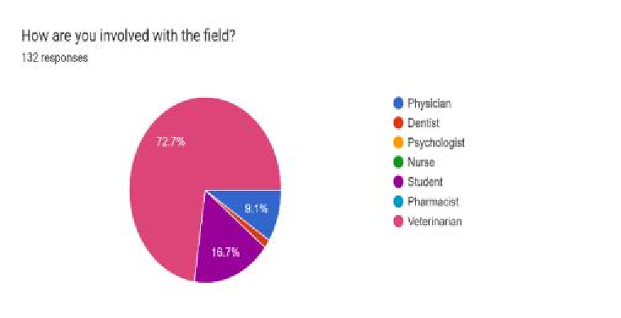

FIGURE:1 – participants’ different job profile; 72.7% are veterinarians,

16.7% are students, 9.1% are physician while rest are dentists

2.2 General Public:

For the general public cohort of 72 respondents, a diverse demographic representation was sought to capture a broad spectrum of perspectives. Participants were recruited through various channels, including social media, community organizations, and public forums. The inclusion criteria considered age, educational background, and general familiarity with AI concepts. Attempts were made to keep it as diverse as possible

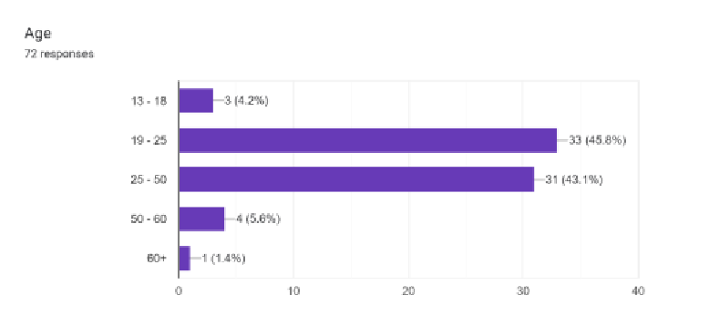

FIGURE 2 – the age bar, majority of our participants form the general public survey were from the age bracket of 19 to 50, showing that youth is heavily invested in AI.

1. Data Collection:

Surveys were distributed electronically using a secure online platform, ensuring ease of access and participation. Health professionals were contacted through professional networks and associations, while the general public was reached through open invitations shared on diverse platforms. The secure online platform was G-Forms

The surveys included questions designed to engage participants at a cognitive level. For instance, health professionals were asked about their confidence in the ethical use of AI, while the general public was queried on their understanding of AI's primary goal and their confidence in its ethical use.

The surveys were administered anonymously, with a unique identifier assigned to each participant to track completion status and prevent duplicate entries. The inclusion of email addresses in the survey for both groups served as the primary means of contact for follow-up communication and distribution of incentives.

1. Data Analysis:

* 1. Quantitative Analysis:

Quantitative data, including Likert-scale responses and demographic information, will be analyzed using statistical tools such as SPSS. Descriptive statistics will provide an overview of participant characteristics, and inferential statistics will identify patterns and correlations in the responses.

* 1. Qualitative Analysis:

Open-ended responses from both surveys will undergo thematic content analysis. Emerging themes and patterns will be identified through an iterative coding process. This qualitative analysis aims to extract rich, context-specific insights that complement the quantitative findings.

1. Ethical Considerations:

This research adheres to ethical principles, including informed consent, confidentiality, and participant privacy. The survey did ask for names, email ids, and age just in case to authenticate the validity of the responses.

1. Timeline:

The data collection phase was scheduled for September to November followed by comprehensive data analysis and interpretation. Results will be compiled, and the final research paper is expected to be completed by January

2024.

In conclusion, this meticulously designed methodology, incorporating specific and targeted survey questions, aims to provide a comprehensive understanding of the diverse perspectives on AI in healthcare. The dualmethod approach ensures a holistic exploration of the research questions, contributing valuable insights to the ongoing discourse on the integration of AI in the medical domain.

# 4. Experimental Setup

The successful execution of this research paper involves a well-structured experimental setup designed to gather comprehensive insights into the perspectives of both health professionals and the general public on the integration of Artificial Intelligence (AI) in healthcare. Through a dualmethod approach comprising surveys targeted at health professionals and laymen, this study seeks to elucidate the multifaceted landscape of AI in healthcare and bridge the gap between technological innovation and societal acceptance.

1. Survey 1: Health Professionals

* 1. Participants:

The health professional cohort consists of 132 respondents, including physicians, nurses, veterinarians, students, and allied health practitioners. This diverse group encompasses varying levels of experience, from those with less than 5 years to those with over 20 years in their respective fields.

* 1. Survey Design:

The survey for health professionals is meticulously crafted to gauge their familiarity with AI applications, opinions on the benefits and challenges of AI in healthcare, and their experiences with AI integration in their practices. Questions delve into the ethical considerations, perceptions of AI's impact on patient care, and the role health professionals envision for themselves in the development and implementation of AI. The questions are designed to engage health professionals at a cognitive level, challenging their intellectual prowess by delving into intricate ethical considerations, discerning perspectives on AI's intricate impact on patient care, and eliciting their insightful vision for their pivotal role in the nuanced development and implementation of AI in healthcare.

* 1. Data Collection:

Surveys were distributed electronically, ensuring ease of participation for health professionals. To maintain anonymity and encourage honest responses, personally identifiable information such as names and contact details will be kept confidential. Email addresses are collected solely for survey distribution and communication purposes and will be stored separately from the survey responses to ensure participant privacy. The survey was administered through secure online platforms (Google Forms), and participants were provided ample time to complete the questionnaire.

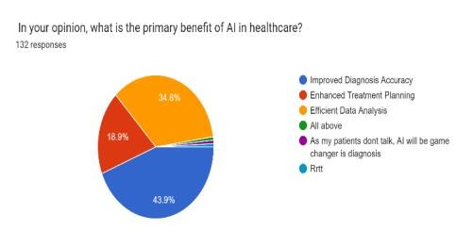

FIGURE 3: for the majority of the respondents ‘improving diagnosis accuracy’ is the primary benefit of AI, closely followed by ‘efficient data analysis’ .

* 1. Data Analysis:

Quantitative data, including responses to Likert-scale questions, will be analyzed using statistical methods to identify trends and patterns. Qualitative data from open-ended responses will undergo thematic analysis to extract nuanced insights. The combined analysis will facilitate a comprehensive understanding of health professionals' perspectives on AI in healthcare.

1. Survey 2: General Public

* 1. Participants:

The general public cohort comprises 72 respondents, spanning various age groups, backgrounds, and levels of familiarity with AI. This group represents the diverse perspectives that constitute the broader community's views on AI in healthcare.

* 1. Survey Design:

Tailored to the layman's perspective, the survey for the general public covers fundamental concepts of AI, perceptions of its role in healthcare, and considerations related to trust, ethics, and job implications. Questions are designed to be accessible to a non-specialized audience, ensuring inclusivity and diverse participation.

* 1. Data Collection:

Similar to the health professional survey, the survey for the general public was distributed electronically, emphasizing user-friendly platforms and a straightforward design. Anonymity is maintained, and participants are encouraged to provide candid responses. The survey window is carefully managed to capture a representative sample.

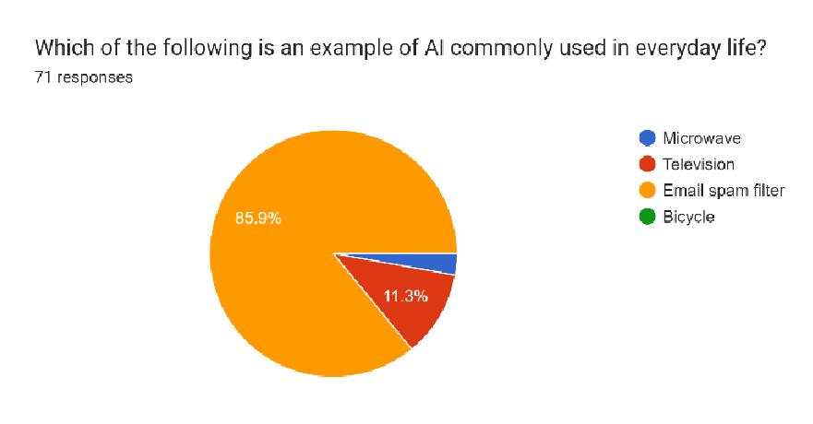

FIGURE 4 – trying to test the common knowledge of people by asking simple questions, to primarily build their confidence for the survey and reassure them that they can differ between commonly used AI tools and not. B.4 Data Analysis:

Quantitative data, including demographic information and Likert-scale responses, will undergo statistical analysis to identify trends and correlations. Qualitative data, such as open-ended responses, will be subjected to content analysis to extract common themes. The synthesis of quantitative and qualitative findings will offer a comprehensive understanding of the general public's perspectives on AI in healthcare.

1. Rigorous Ethical Considerations:

This research adheres to ethical guidelines, ensuring informed consent, confidentiality, and privacy for all participants. The study is designed to minimize any potential biases, and data will be securely stored and accessed only by the research team.

1. Timeline:

The survey administration and data collection phase are planned till the month of November of 2023. Subsequent data analysis, interpretation, and report compilation will follow promptly, allowing for timely dissemination of findings.

In essence, the experimental setup for this research paper is meticulously crafted to capture diverse perspectives from health professionals and the general public, employing surveys that are methodologically sound, ethically robust, and designed to contribute rich insights to the discourse on the role of AI in healthcare. Through this dual-method approach, the study aims to foster a nuanced understanding of the opportunities and challenges surrounding the integration of AI in the medical domain.

# 5. Result and Inference

Multiple questions yield multiple outcomes which feed our imaginations and

therefore give space to inferences;

Survey 1: Health Professionals

The survey results offer a comprehensive glimpse into the perspectives of health professionals regarding the integration of Artificial Intelligence (AI) in healthcare. Among the respondents, the majority identified as veterinarians (72.7%), followed by students (16.7%), physicians (9.1%), and dentists (1.5%). Notably, a significant portion of participants (39.4%) reported having over 20 years of experience, indicating a wealth of professional knowledge within the surveyed group. Concerning familiarity with AI, 47% of respondents consider themselves somewhat familiar with current AI applications in healthcare, while 16.7% express a very familiar stance. In contrast, 20.5% claim to have little to no familiarity with AI. The perceived primary benefits of AI align with improved diagnosis accuracy (43.9%) and efficient data analysis (34.8%). A substantial majority (83.2%) believes AI has the potential to revolutionize patient care, with 31.8% strongly agreeing and 52.3% agreeing.

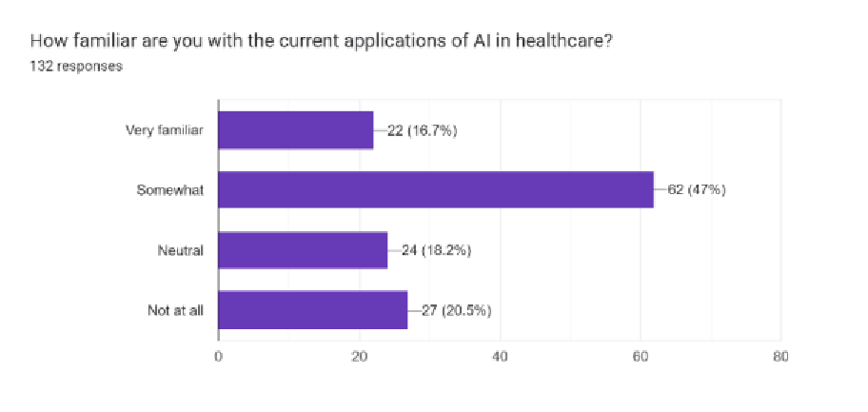

Participants generally exhibit confidence in the ethical use of AI, with 29.5% being very confident and 36.4% somewhat confident. However, a notable portion (33.3%) reports that AI has not yet been effectively integrated into their healthcare practice. Diagnostic imaging emerges as the area where AI is perceived to have the most positive impact (61.4%), overshadowing administrative tasks (14.4%), drug discovery (11.4%), and personalized imaging (9.8%). Concerns regarding AI predominantly center around data security (54.5%), followed by concerns about decision-making (28%) and job displacement (25.8%). A substantial proportion (64.4%) believes AI can contribute to reducing healthcare costs, with 40.2% strongly agreeing. While health professionals are generally optimistic about patient receptivity to AIassisted care (55.1%), concerns about patient reluctance (10.6%) and complete non-receptivity (2.3%) are noted.

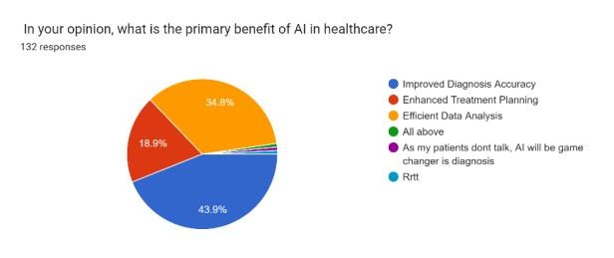

Regarding professional involvement in AI, a significant majority (62.1%) believes healthcare professionals should collaborate with AI experts, indicating a collective vision for a synergistic partnership in AI development and implementation. Participants recognize AI's potential in preventive healthcare measures, with 84.8% acknowledging its significant (43.9%) or moderate (40.9%) contribution. The importance of ongoing education and training on AI is underscored, as 60.6% consider it absolutely essential.

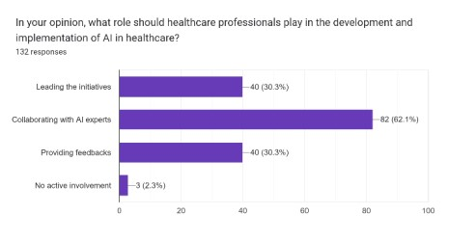

Survey 2: General Public

In terms of the understanding of AI, a majority of respondents (87.5%) define it as "machines programmed to perform," indicating a fundamental grasp of the technology. However, a noteworthy percentage associates AI with concepts like an advanced robot (8.3%) or a human-like robot (15.3%). This suggests varying levels of familiarity and interpretation of AI among the general public. Familiarity with AI in healthcare reveals a mixed landscape, with 9.7% claiming to be very familiar and 56.9% considering themselves somewhat familiar. However, a significant 26.4% maintain a neutral stance, and 12.5% profess to have no familiarity at all. This suggests a need for increased awareness and education regarding AI applications in the healthcare domain. In terms of perceived benefits, a majority of respondents (65.3%) believe that the primary advantage of using AI in healthcare lies in improved diagnosis accuracy. Nevertheless, a noteworthy percentage (29.2%) remains uncertain about the benefits, indicating a level of ambiguity or lack of clarity among the respondents.

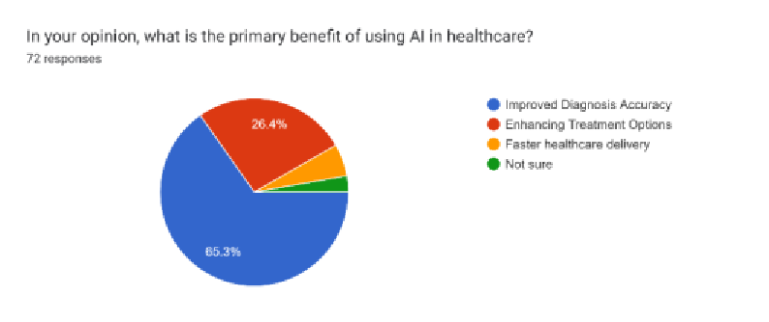

Regarding cost reduction and preventive healthcare, respondents largely agree that AI can contribute positively, with 58.3% supporting the idea of AI reducing healthcare costs and 83.3% acknowledging its potential in preventive healthcare measures. Perceptions around comfort with AI-made medical decisions showcase a nuanced landscape. While 36.1% express comfort or some level of comfort with the idea of AI making medical decisions without human intervention, 40% express discomfort to varying degrees. This points to the need for addressing public concerns around trust and decision-making autonomy. In terms of attitudes toward doctors using AI, the majority of respondents (68.1%) support doctors incorporating AI into their practice. However, there is a range of perspectives on the future role of AI in advancing healthcare, with 43.1% expressing disagreement. Trust in information provided by AI shows a diverse range of responses, with 52.8% maintaining a neutral stance, indicating a level of caution or uncertainty among the respondents.

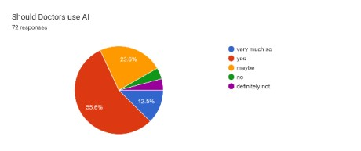

**Responses to Survey 1:**

After answering all the questions, the responses by the health professionals show a positive trend as they are willing to give the use of artificial intelligence a try. It shows that with growing buzz around the subject matter has helped the medical community accept this idea with open arms and operate without fear. While they are still in the grey when it comes to security;

with legitimate questions over all it is a positive trend **Responses to Survey 2:**

The responses collected from people of various age groups and diverse background shows that although the news, the buzz, and the speculation around Artificial Intelligence is new, it has penetrated the walls of diversity and made its space. The understanding to it might not be accurate or even similar but the basic idea has been conveyed. People seem supportive of it and some even advocate its usage in day-to-day usage in the field of medical sciences. The obvious issue is with the security, which can only be solved by educating the people about AI, propagating its benefits and putting in place a regulatory body to assure of security.

# 6. Conclusion

The survey of health professionals reveals a nuanced landscape of attitudes and experiences regarding AI in healthcare. With a significant number of respondents being veterinarians (72.7%), the diversity of professional backgrounds, including students, physicians, and dentists, enriches the comprehensiveness of the findings. The majority of health professionals express optimism about AI's potential to revolutionize patient care (83.2%), particularly in diagnostic imaging (61.4%). While confidence in the ethical use of AI is notable (66.1%), concerns about data security (54.5%) and challenges in explaining AI-based recommendations to patients (51.5%) underscore the need for ongoing dialogue and education. The health professionals' survey also highlights a consensus on the essential role of ongoing education and training for healthcare professionals (60.6%) and the need for collaborative efforts with AI experts (62.1%). These findings emphasize the importance of fostering partnerships, facilitating continuous learning, and addressing ethical considerations to ensure the responsible and effective integration of AI in healthcare practices.

On the other hand, the general public survey unveils diverse attitudes, ranging from positive acceptance to cautious optimism and concerns. While a significant percentage recognizes the potential benefits of AI, such as improved diagnosis accuracy (65.3%) and positive impacts on patient care (86.1%), there exists a notable degree of uncertainty, particularly regarding familiarity with AI applications in healthcare (26.4%) and trust in AIgenerated information (52.8%). Concerns about job displacement due to AI (40.3%) and mixed sentiments about the future role of AI in advancing healthcare (43.1% disagreement) highlight the importance of addressing societal apprehensions. The general public's cautious optimism and the recognition of potential benefits, coupled with concerns, underscore the need for transparent communication, educational initiatives, and ethical frameworks to build trust and ensure informed decision-making.

The insights garnered from these surveys lay the foundation for future research and initiatives at the intersection of AI and healthcare, such as; Ethical considerations are paramount, demanding further research for tailored frameworks addressing data security, decision transparency, and patientdoctor dynamics. The imperative for ongoing education among health professionals signals the need for targeted programs ensuring their seamless collaboration with AI. Patient-centric strategies must be developed to enhance public understanding and trust. Addressing job displacement concerns requires broader socio-economic assessments and mitigation plans. Lastly, longitudinal studies are essential for tracking evolving perceptions, attitudes, and experiences, providing insights for ongoing adaptation to AI in healthcare. This multifaceted strategy aims to create an ethical, informed, and inclusive foundation for the harmonious integration of AI into healthcare

# 8. Acknowledgements

I would like to express my sincere gratitude to Professor Dr. Deeba Kannan, who served as the guiding force and mentor throughout the course of this research. Their valuable insights have been instrumental in shaping the direction and quality of this paper. I extend my heartfelt thanks to all the health professionals and members of the general public who participated in the surveys. Your willingness to contribute your perspectives and experiences has been crucial in enriching the depth and breadth of our research findings.

# References

1. R. Y. Cohen and V. P. Kovacheva, "A Methodology for a Scalable, Collaborative, and Resource-Efficient Platform, MERLIN, to Facilitate Healthcare AI Research," in IEEE Journal of Biomedical and Health Informatics, vol. 27, no. 6, pp. 3014-3025, June 2023, doi: 10.1109/JBHI.2023.3259395.

1. M. Moreb, T. A. Mohammed and O. Bayat, "A Novel Software Engineering Approach Toward Using Machine Learning for Improving the Efficiency of Health Systems," in IEEE Access, vol. 8, pp. 23169-23178, 2020, doi: 10.1109/ACCESS.2020.2970178.

1. C. -T. Wu et al., "A Precision Health Service for Chronic Diseases: Development and Cohort Study Using Wearable Device, Machine Learning, and Deep Learning," in IEEE Journal of Translational Engineering in Health and Medicine, vol. 10, pp. 1-14, 2022, Art no. 2700414, doi: 10.1109/JTEHM.2022.3207825.

1. J. Esch, "A Survey on Ambient Intelligence in Healthcare," in Proceedings of the IEEE, vol. 101, no. 12, pp. 2467-2469, Dec. 2013, doi: 10.1109/JPROC.2013.2286654.

1. S. Fouladvand et al., "A Comparative Effectiveness Study on Opioid Use Disorder Prediction Using Artificial Intelligence and Existing Risk Models," in IEEE Journal of Biomedical and Health Informatics, vol. 27, no. 7, pp. 3589-3598, July 2023, doi:

10.1109/JBHI.2023.3265920.

1. N. Reamaroon, M. W. Sjoding, K. Lin, T. J. Iwashyna and K. Najarian, "Accounting for Label Uncertainty in Machine Learning for Detection of Acute Respiratory Distress Syndrome," in IEEE Journal of Biomedical and Health Informatics, vol. 23, no. 1, pp. 407415, Jan. 2019, doi: 10.1109/JBHI.2018.2810820.

1. M. Jamshidi et al., "Artificial Intelligence and COVID-19: Deep Learning Approaches for Diagnosis and Treatment," in IEEE Access, vol. 8, pp. 109581-109595, 2020, doi:

10.1109/ACCESS.2020.3001973.

1. Q. Zhang, Y. Liu, H. Han, J. Shi and W. Wang, "Artificial Intelligence Based Diagnosis for Cervical Lymph Node Malignancy Using the Point-Wise Gated Boltzmann Machine," in IEEE Access, vol. 6, pp. 60605-60612, 2018, doi: 10.1109/ACCESS.2018.2873043.

1. D. K. Luu et al., "Artificial Intelligence Enables Real-Time and Intuitive Control of Prostheses via Nerve Interface," in IEEE Transactions on Biomedical Engineering, vol. 69, no. 10, pp. 3051-3063, Oct. 2022, doi: 10.1109/TBME.2022.3160618.

1. Z. Liu et al., "AttentiveHerb: A Novel Method for Traditional Medicine Prescription

Generation," in IEEE Access, vol. 7, pp. 139069-139085, 2019, doi:

10.1109/ACCESS.2019.2941503.

1. M. E. H. Chowdhury et al., "Can AI Help in Screening Viral and COVID-19 Pneumonia?," in IEEE Access, vol. 8, pp. 132665-132676, 2020, doi:

10.1109/ACCESS.2020.3010287.

1. G. Muhammad and M. Alhussein, "Convergence of Artificial Intelligence and Internet of Things in Smart Healthcare: A Case Study of Voice Pathology Detection," in IEEE Access, vol. 9, pp. 89198-89209, 2021, doi: 10.1109/ACCESS.2021.3090317.

1. D. Ravì et al., "Deep Learning for Health Informatics," in IEEE Journal of Biomedical and Health Informatics, vol. 21, no. 1, pp. 4-21, Jan. 2017, doi:

10.1109/JBHI.2016.2636665.

1. A. Chaddad, L. Hassan, Y. Katib and A. Bouridane, "Deep Survival Analysis With Clinical Variables for COVID-19," in IEEE Journal of Translational Engineering in Health and Medicine, vol. 11, pp. 223-231, 2023, doi: 10.1109/JTEHM.2023.3256966.

1. D. Dahiwade, G. Patle and E. Meshram, "Designing Disease Prediction Model Using Machine Learning Approach," 2019 3rd International Conference on Computing Methodologies and Communication (ICCMC), Erode, India, 2019, pp. 1211-1215, doi:

10.1109/ICCMC.2019.8819782.

1. M. Bernardini, L. Romeo, P. Misericordia and E. Frontoni, "Discovering the Type 2 Diabetes in Electronic Health Records Using the Sparse Balanced Support Vector Machine," in IEEE Journal of Biomedical and Health Informatics, vol. 24, no. 1, pp. 235246, Jan. 2020, doi: 10.1109/JBHI.2019.2899218.

1. S. U. Amin and M. S. Hossain, "Edge Intelligence and Internet of Things in Healthcare: A Survey," in IEEE Access, vol. 9, pp. 45-59, 2021, doi:

10.1109/ACCESS.2020.3045115.

1. S. Saravanan, K. Ramkumar, K. Narasimhan, S. Vairavasundaram, K. Kotecha and A. Abraham, "Explainable Artificial Intelligence (EXAI) Models for Early Prediction of Parkinson’s Disease Based on Spiral and Wave Drawings," in IEEE Access, vol. 11, pp. 68366-68378, 2023, doi: 10.1109/ACCESS.2023.3291406.

1. S. Lee, S. Kim, J. Lee, J. -Y. Kim, M. -H. Song and S. Lee, "Explainable Artificial Intelligence for Patient Safety: A Review of Application in Pharmacovigilance," in IEEE Access, vol. 11, pp. 50830-50840, 2023, doi: 10.1109/ACCESS.2023.3271635.

1. F. Giuste et al., "Explainable Artificial Intelligence Methods in Combating Pandemics: A Systematic Review," in IEEE Reviews in Biomedical Engineering, vol. 16, pp. 5-21, 2023, doi: 10.1109/RBME.2022.3185953.

1. A. Chaddad et al., "Explainable, Domain-Adaptive, and Federated Artificial Intelligence in Medicine," in IEEE/CAA Journal of Automatica Sinica, vol. 10, no. 4, pp.

859-876, April 2023, doi: 10.1109/JAS.2023.123123.

1. N. Liu, S. Kumara and E. Reich, "Gaining Insights Into Patient Satisfaction Through Interpretable Machine Learning," in IEEE Journal of Biomedical and Health Informatics, vol. 25, no. 6, pp. 2215-2226, June 2021, doi: 10.1109/JBHI.2020.3038194.

1. G. Dhekshagna, G. Sushmitha and U. Sairam, "Geriatric Disease Prediction: A Study on Age-Based Disease Prognostication," 2023 2nd International Conference on Edge Computing and Applications (ICECAA), Namakkal, India, 2023, pp. 983-986, doi:

10.1109/ICECAA58104.2023.10212172.

1. G. Tsang, X. Xie and S. -M. Zhou, "Harnessing the Power of Machine Learning in Dementia Informatics Research: Issues, Opportunities, and Challenges," in IEEE Reviews in Biomedical Engineering, vol. 13, pp. 113-129, 2020, doi:

10.1109/RBME.2019.2904488.

1. J. Al-Jaroodi, N. Mohamed, N. Kesserwan and I. Jawhar, "Healthcare 4.0 – Managing a Holistic Transformation," 2022 IEEE International Systems Conference (SysCon), Montreal, QC, Canada, 2022, pp. 1-8, doi: 10.1109/SysCon53536.2022.9773863.

1. G. Yang et al., "Homecare Robotic Systems for Healthcare 4.0: Visions and Enabling Technologies," in IEEE Journal of Biomedical and Health Informatics, vol. 24, no. 9, pp.

2535-2549, Sept. 2020, doi: 10.1109/JBHI.2020.2990529.

1. T. Zhou, J. Shen, D. He, P. Vijayakumar and N. Kumar, "Human-in-the-Loop-Aided Privacy-Preserving Scheme for Smart Healthcare," in IEEE Transactions on Emerging Topics in Computational Intelligence, vol. 6, no. 1, pp. 6-15, Feb. 2022, doi:

10.1109/TETCI.2020.2993841.